1. If you are using a proxy to connect to the Fusion instance, it is important to setup proxy for FRS also.

<https://docs.oracle.com/cloud/latest/pbcs_common/UPBCS/fr_studio_proxy.htm#UPBCS-new_using_pbcs_book_320>

* On the computer that hosts Financial Reporting Studio, open Windows Registry Editor.
* Navigate to the virtual machine setting of Financial Reporting Studio. The path, generally, is HKEY_LOCAL_MACHINE\SOFTWARE\Wow6432Node\Hyperion Solutions\Hyperion Reports\HReports\JVM.
* Increment the current JVMOptionCount by two:
* Right-click JVMOptionCount and select Modify.
* Select Decimal as the base for the value data.
* Increase the current value in Value Data by two. For example, if the current vale is 14, enter 16 in Value Data. Click OK

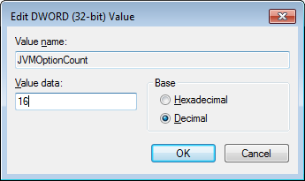

* Add two string values: One for proxyHost and one for proxyPort

|  |  |  |
| --- | --- | --- |
| Name | Type | Value |
| JVMOption15 | REG_SZ | -Dhttps.proxyHost=www-proxy.us.oracle.com |
| JVMOption16 | REG_SZ | -Dhttps.proxyPort=80 |

* Right-click JVM, then New, and then String Value.
* Enter the string value name; for example, **JVMOption15**.
* Right-click the string value that you created (for example, JVMOption15), and then select Modify.
* In Value Data, enter data; for example, **-Dhttps.proxyHost=www-proxy.us.oracle.com.** Click OK

Similarly create the proxyPort String Value also.

